Lab 2: Inheritance and Polymorphism

Background
A company has three employee categories: Salaried, Wages and Part-time. All employees share common attributes such as employee ID, name, and SIN.
- Salaried employees have ID numbers starting with 0–4.
- Wages employee’s have IDs starting with 5–7.
- Part-time employee’s have IDs starting with 8–9.

All employees are paid weekly and with their payment calculated as follows:
- Salaried employees: Paid a fixed salary each week.
- Wages employees: Paid using the formula:
Pay = Hourly Rate * Work Hours + Overtime Pay (if any)
  - Overtime is paid at 1.5x the hourly rate for any hours worked over 40 in one week.
- Part-time employees: Paid using the formula:
Par = Hourly Rate * Work Hours
  - No overtime pay is given.

Instructions
- Create the classes as shown in the diagram on the following page.
- Place the data file employees.txt in the res folder with data organized as follows:
  - Employee ID, name, address, phone, sin, dob, dept, (HourlyRate, hoursWorked) or yearly salary
- Create an inheritance tree whereby Salaried, PartTime and Wages inherit from Employee.
- Write a Java application that implements and invokes the following methods to produce the given sample output:
  - Read data from employee.txt and create objects based on employee type. Fill a list called employees with objects based on the supplied data file.
  - Calculate and return the average weekly pay for all employees.
  - Calculate and return the name of a Wages employee with the highest weekly pay.

  - Calculate and return the name of a Salaried employee with the lowest weekly pay.
  - Calculate and return the percentage of Salaried employees.
  - Calculate and return the percentage of Wages employees.
  - Calculate and return the percentage of Part Time employees.

  - 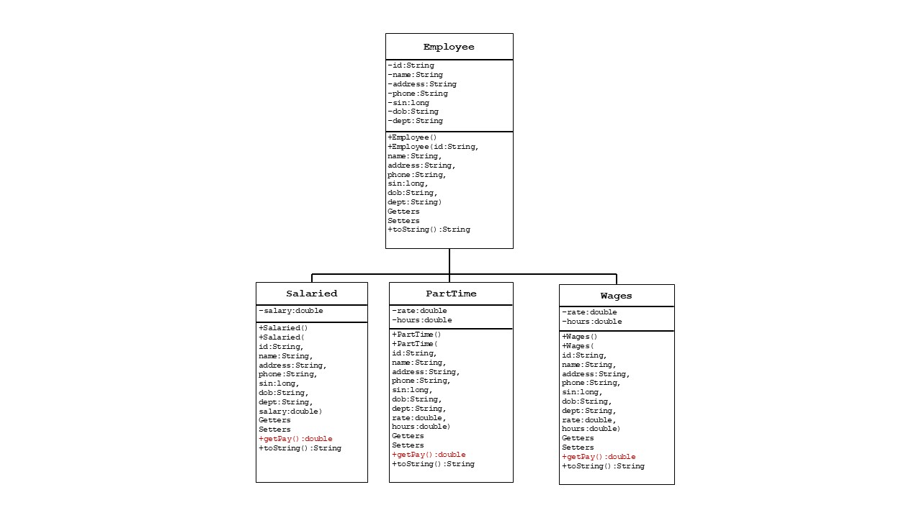

Sample Output
